

Branding Guidelines

Color palette
100% is primary colors
80% - 10% are secondary colors

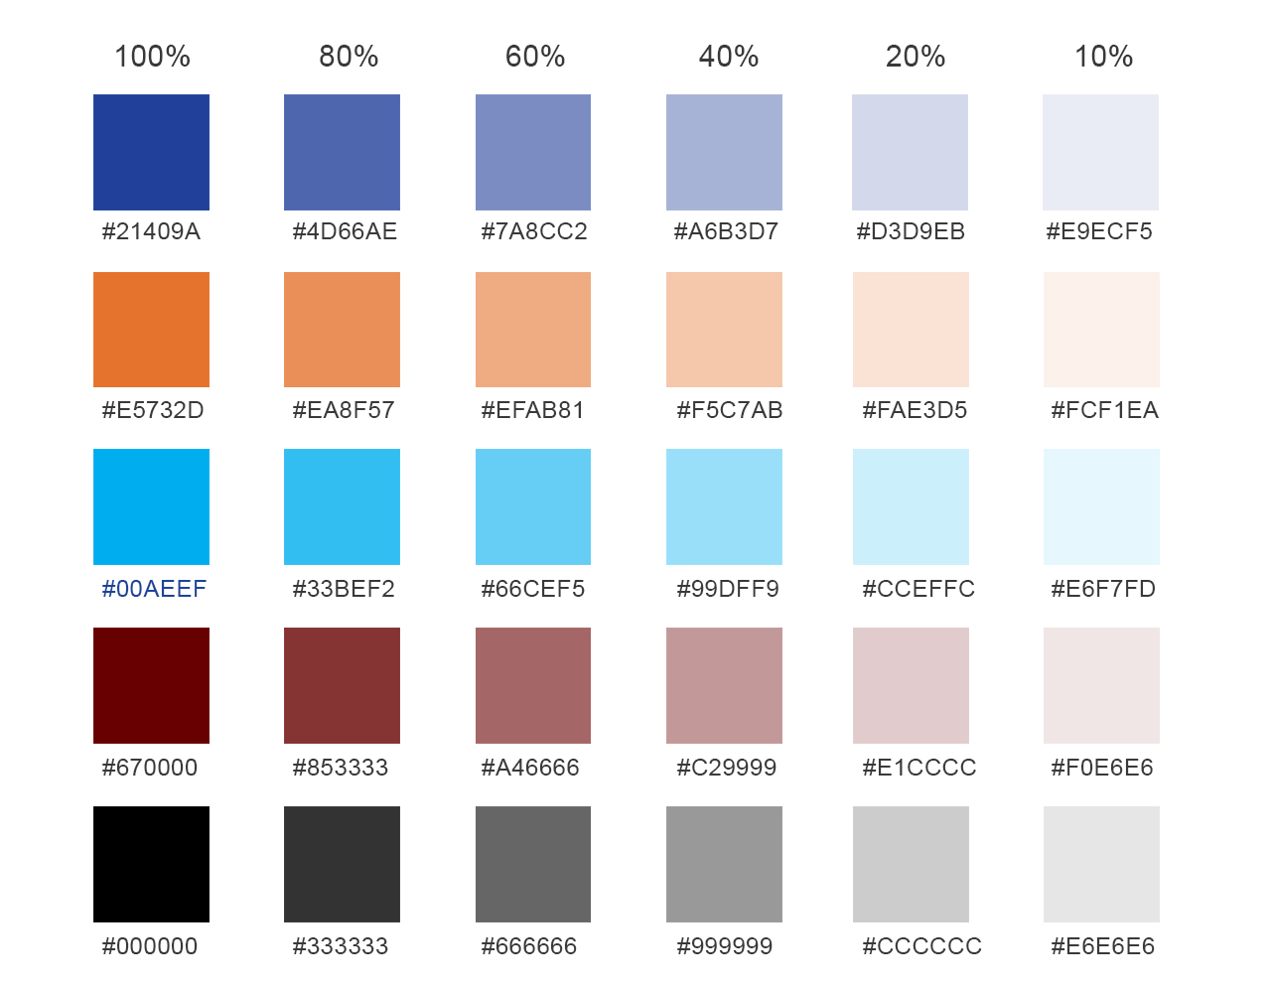

340Best Primary colors

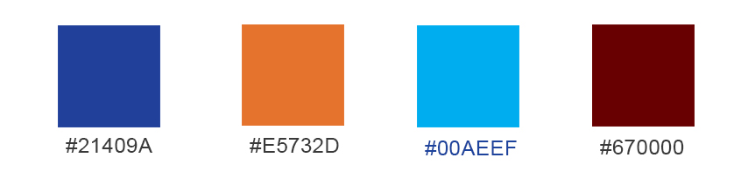

Action colors

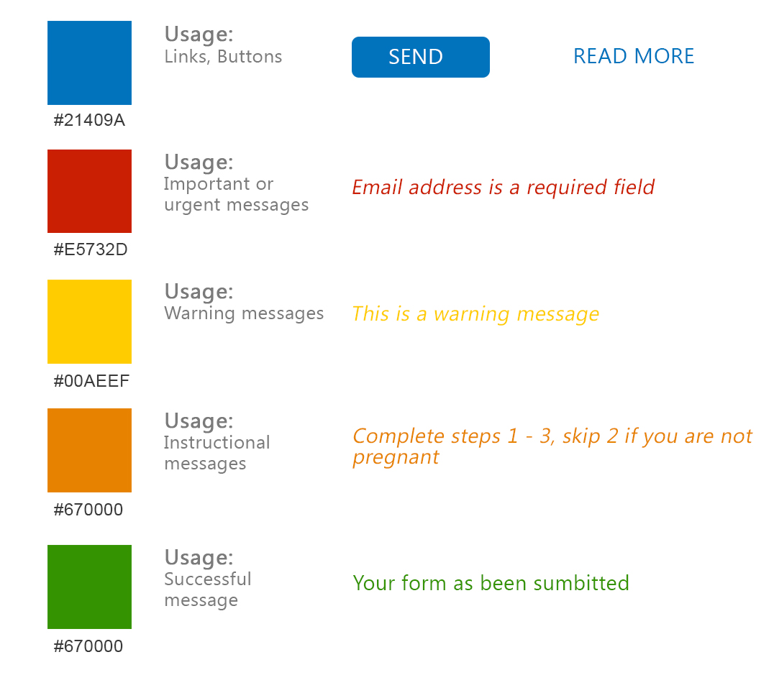

Typography

